Contents
11.6.1 Lab – Basic OSPF Configuration Answers
Topology
Instructions:
Task 2: Basic Router Configurations
Task 3: Configure and Activate Serial and Ethernet Addresses
Step 1: Configure the interfaces of R1, R2 and R3.
Step 2: Verify IP addressing and interfaces.
Step 3: Configure the Ethernet interfaces of PC1, PC2 and PC3.
Step 4: Test the PC configuration by executing a ping from the PC to the default gateway.
Task 4: Configure OSPF on the R1 Router
Step 1: Use the router ospf command in global configuration mode to enable OSPF on router R1.
Step 2: Configure the network statement for the LAN network.
Step 3: Configure the router to notify the 192.168.10.0/30 network connected to the Serial0/0/0 interface.
Step 4: Configure the router to notify the network 192.168.10.4/30 connected to interface Serial0/0/1.
Step 5: When you are done with OSPF configuration for R1, return to privileged EXEC mode.
Task 5: Configure OSPF on the R2 and R3 Routers
Step 1: Enable OSPF routing on router R2 using the router ospf command.
Step 2: Configure the router to report LAN 10.10.10.0/24 for OSPF updates.
Step 3: Configure the router to notify the 192.168.10.0/30 network connected to the Serial0/0/0 interface.
Step 4: Configure the router to notify the 192.168.10.8/30 network connected to the Serial0/0/1 interface.
Step 5: Configure OSPF on router R3 using the router ospf and network commands.
Task 6: Configure OSPF Router IDs
Step 1: Examine the current router IDs in the topology.
Step 2: Use loopback addresses to change the router IDs of the routers in the topology.
Step 3: Reload the routers to force the new router IDs to be used.
Step 4: Use the show ip ospf neighbors command to verify that the router IDs have been changed
Step 5: Use the router-id command to change the router ID on router R1.
Step 6: Use the show ip ospf neighbor command on router R2 to verify that R1’s router ID has been changed.
Step 7: Delete the configured router ID with the no form of the router-id command.
Step 8: Restart the OSPF process using the clear ip ospf process command.
Task 7: Verify OSPF Operation
Step 1: On router R1, use the show ip ospf neighbor command to display information about the OSPF neighbor routers R2 and R3.
Step 2: On router R1, use the show ip protocols command to view information about routing protocol operations.
Task 8: Examine OSPF Routes in the Routing Tables
Task 9: Configure OSPF Cost
Step 1: Use the show ip route command on router R1 to display the OSPF cost to reach network 10.10.10.0/24.
Device | Interface | IP Address | Subnet Mask | Default Gateway
R1 | Fa0/0 | 172.16.1.17 | 255.255.255.240 | N/A
R1 | S0/0/0 | 192.168.10.1 | 255.255.255.252 | N/A
R1 | S0/0/1 | 192.168.10.5 | 255.255.255.252 | N/A
R2 | Fa0/0 | 10.10.10.1 | 255.255.255.0 | N/A

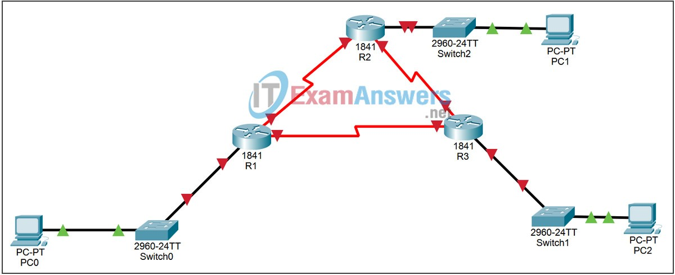
11.6.1 Lab – Basic OSPF Configuration Answers
Topology

Device | Interface | IP Address | Subnet Mask | Default Gateway
 | S0/0/0 | 192.168.10.2 | 255.255.255.252 | N/A
 | S0/0/1 | 192.168.10.9 | 255.255.255.252 | N/A
R3 | Fa0/0 | 172.16.1.33 | 255.255.255.248 | N/A
R3 | S0/0/0 | 192.168.10.6 | 255.255.255.252 | N/A
R3 | S0/0/1 | 192.168.10.10 | 255.255.255.252 | N/A
PC0 | NIC | 172.16.1.20 | 255.255.255.240 | 172.16.1.17
PC1 | NIC | 10.10.10.10 | 255.255.255.0 | 10.10.10.1
PC2 | NIC | 172.16.1.35 | 255.255.255.248 | 172.16.1.33
Instructions:

Learning Objectives
Cable a network according to the Topology Diagram.
Erase the startup configuration and reload a router to the default state.
Perform basic configuration tasks on a router.
Configure and activate interfaces.
Configure OSPF routing on all routers.
Configure OSPF router IDs.
Verify OSPF routing using show commands. Configure a static default route.
Propagate default route to OSPF neighbors.
Configure OSPF Hello and Dead Timers.
Configure OSPF on a Multiaccess network.
Configure OSPF priority.
Understand the OSPF election process. Document the OSPF configuration.

Task 2: Basic Router Configurations

Perform basic configuration of the R1, R2, and R3 routers according to the following guidelines:
Configure the router hostname
Disable DNS lookup
Configure the EXEC mode password as class
Configure a password for console connections as cisco (case sensitive)
Configure a password for VTY connections as cisco (case sensitive)

Task 3: Configure and Activate Serial and Ethernet Addresses

Step 1: Configure the interfaces of R1, R2 and R3.
Configure the interfaces of routers R1, R2, and R3 with the IP addresses from the table below the Topology Diagram.

R1
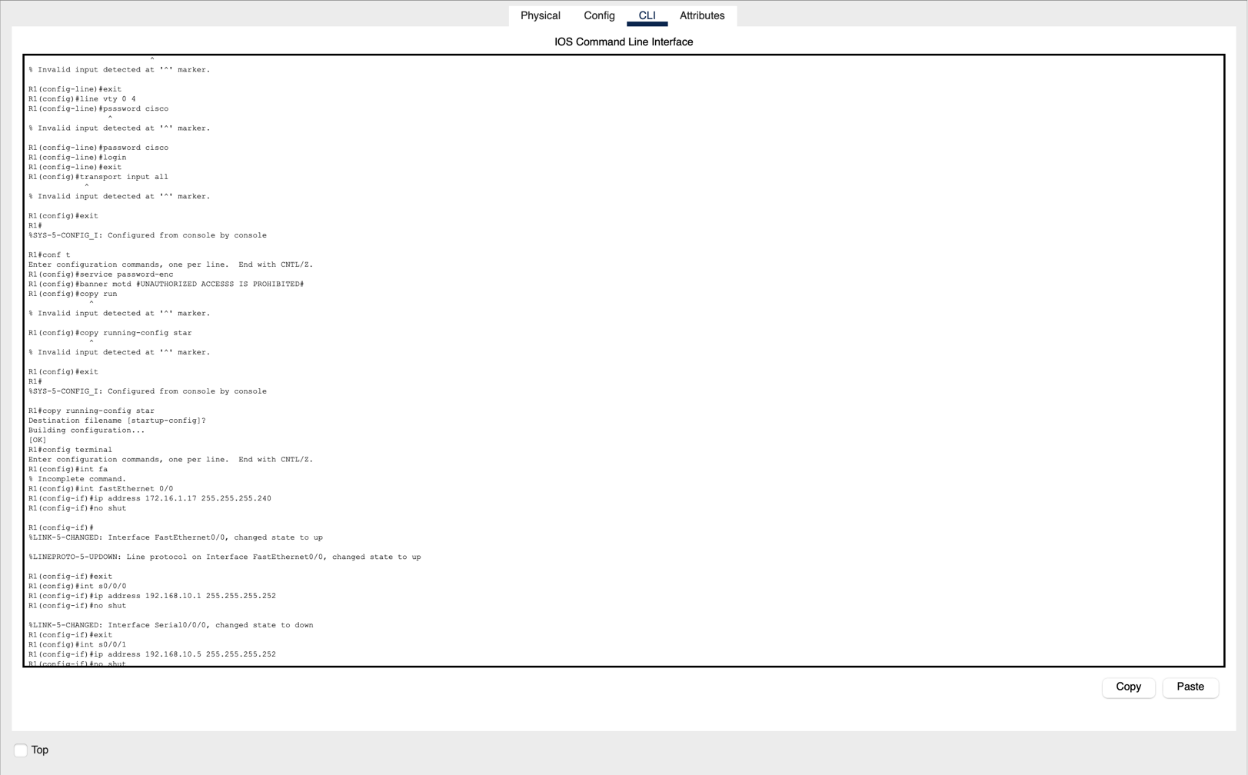
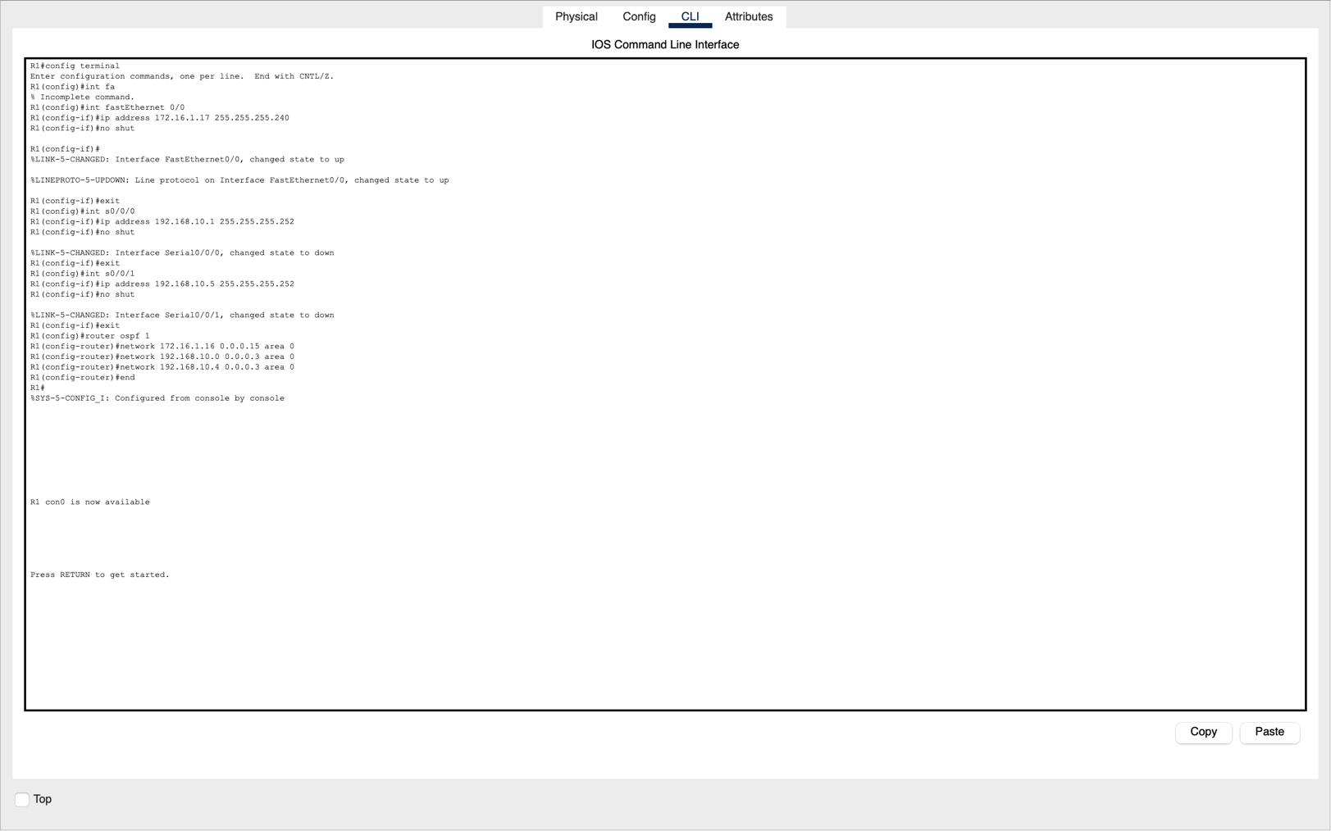

R2
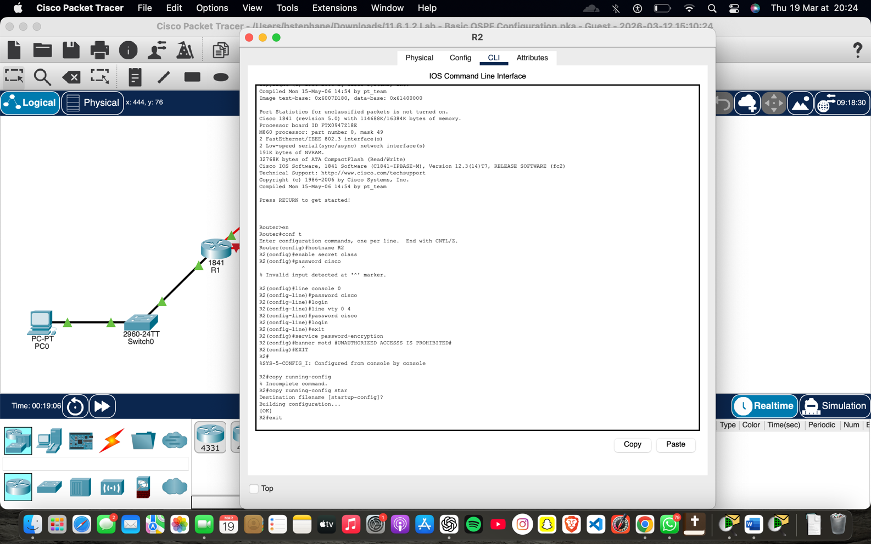
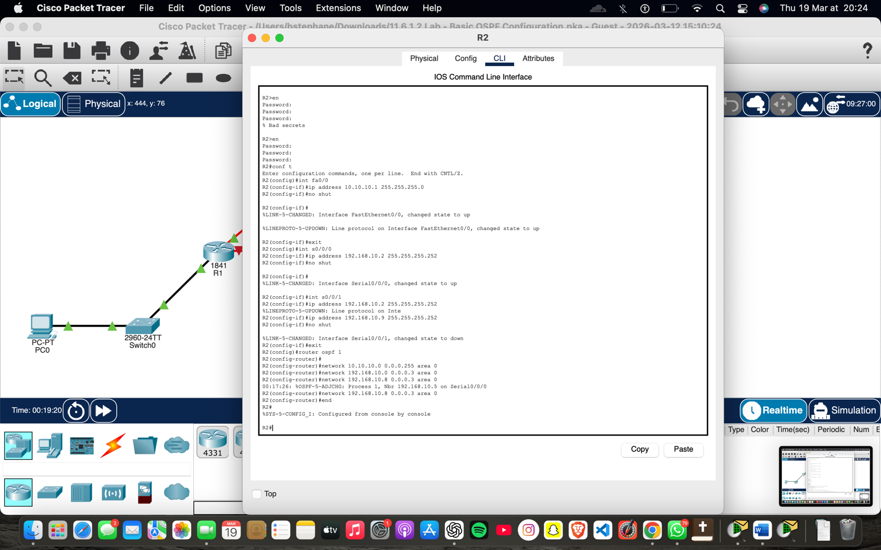

R3
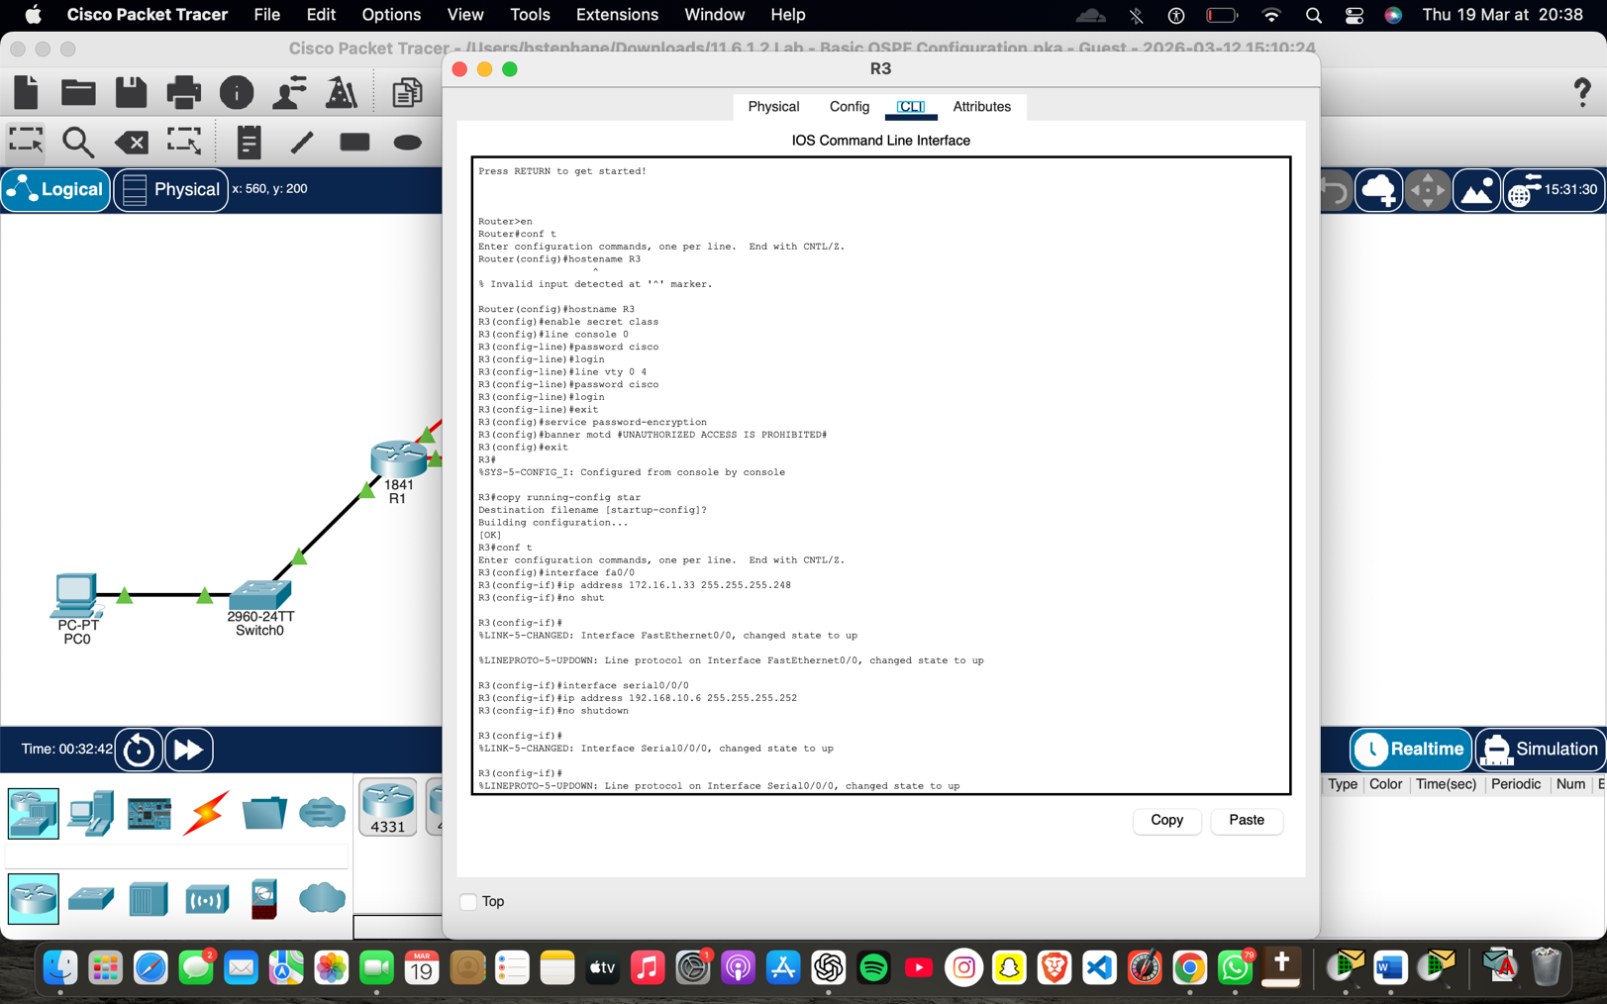

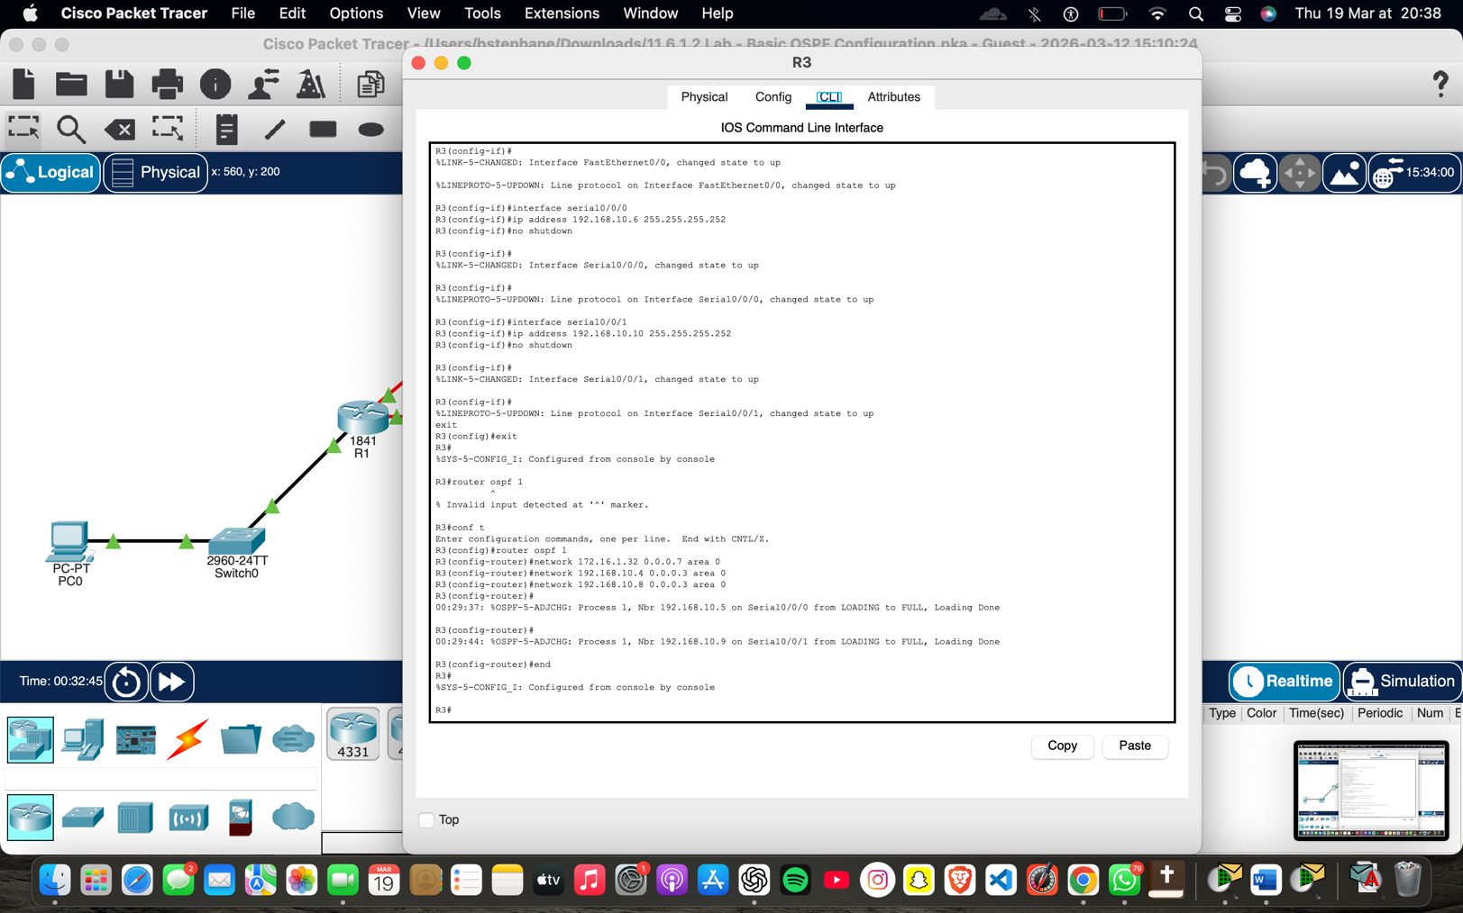

Task 6: Configure OSPF Router IDs

The OSPF router ID is used to uniquely identify the router in the OSPF routing domain. A router ID is an IP address. Cisco routers derive the router ID in one of three ways and with the following priority:
- IP address configured with the OSPF router-id command.
- Highest IP address of any of the router’s loopback addresses.
- Highest active IP address of any of the router’s physical interfaces.
Step 2: Use loopback addresses to change the router IDs of the routers in the topology.
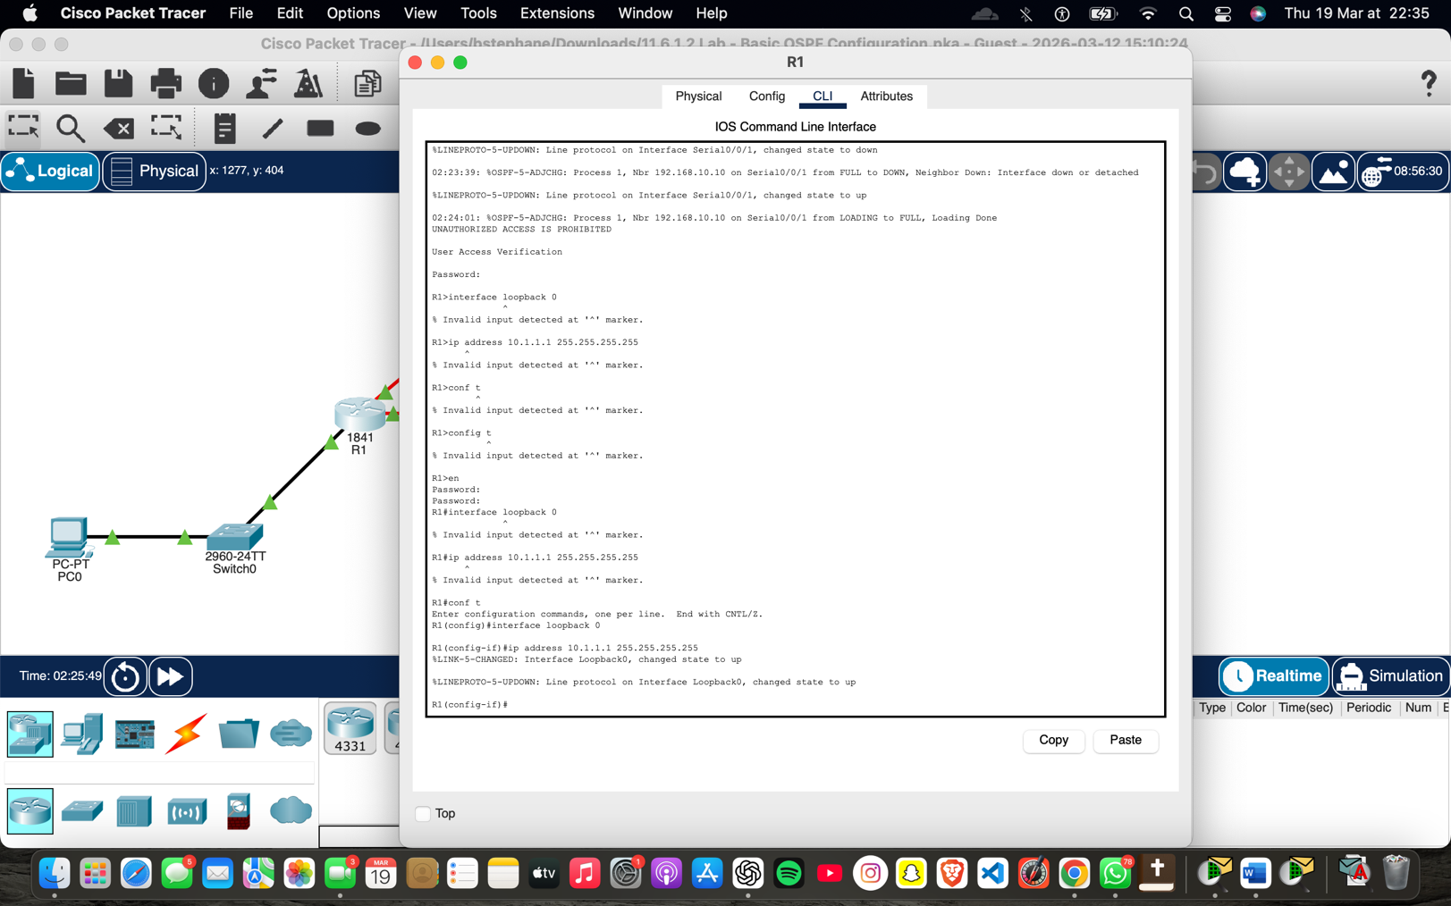
Step 4: Use the show ip ospf neighbors command to verify that the router IDs have been changed
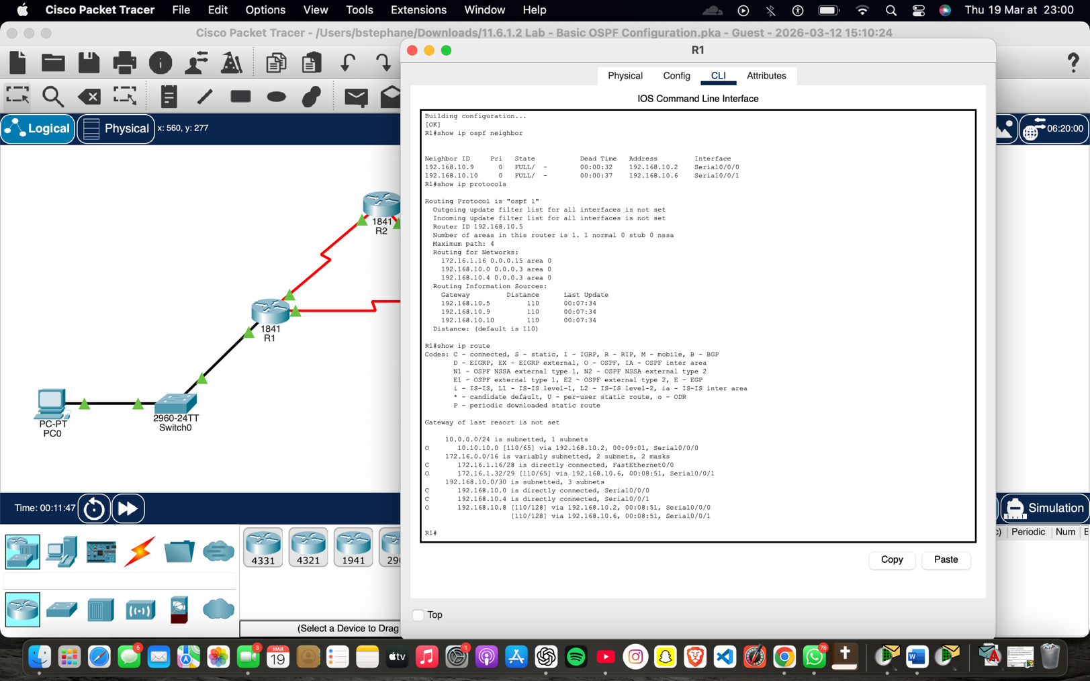
If this command is used on an OSPF router process that is already active (that has neighbors), the new router ID is used on the next reload or restart of the manual OSPF process. To restart the OSPF process manually, use the clear ip ospf process command.
R1#(config-router)#end
R1# clear ip ospf process
Reset ALL OSPF processes? [no]:yes R1#
Step 6: Use the show ip ospf neighbor command on router R2 to verify that R1’s router ID has been changed.
R2#show ip ospf neighbor
Neighbor ID Pri State Dead Time Address Interface
10.3.3.3 0 FULL/ - 00:00:36 192.168.10.10 Serial0/0/1
10.4.4.4 0 FULL/ - 00:00:37 192.168.10.1 Serial0/0/0
 
Step 7: Delete the configured router ID with the no form of the router-id command.
R1(config)#router ospf 1
R1(config-router)#router-id 10.4.4.4
Reload or use “clear ip ospf process” command, for this to take effect
Step 8: Restart the OSPF process using the clear ip ospf process command.
Restarting the OSPF process forces the router to use the IP address configured on interface loopack 0 as the router ID.
R1(config-router)#end
R1# clear ip ospf process
Reset ALL OSPF processes? [no]:yes R1#

Task 7: Verify OSPF Operation

Step 1: On router R1, use the show ip ospf neighbor command to display information about the OSPF neighbor routers R2 and R3.
You should see the neighbor ID and IP address of each adjacent router and the interface that R1 uses to reach that OSPF neighbor.
R1#show ip ospf neighbor
Neighbor ID Pri State Dead Time Address Interface
10.2.2.2 0 FULL/- 00:00:32 192.168.10.2 Serial0/0/0
10.3.3.3 0 FULL/- 00:00:32 192.168.10.6 Serial0/0/1 R1#
Step 2: On router R1, use the show ip protocols command to view information about routing protocol operations.
Notice that the information that was configured in the previous Tasks, such as the protocol, process ID, neighbor ID, and networks, are displayed in the output. The IP addresses of adjacent neighbors are also displayed.
R1#show ip protocols
Routing Protocol is "ospf 1"
Outgoing update filter list for all interfaces is not set Incoming update filter list for all interfaces is not set
Router ID 10.1.1.1
Number of areas in this router is 1. 1 normal 0 stub 0 nssa
Maximum path: 4 Routing for Networks:
172.16.1.16 0.0.0.15 area 0
192.168.10.0 0.0.0.3 area 0
192.168.10.4 0.0.0.3 area 0
Routing Information Sources:
Gateway Distance Last Update
10.2.2.2 110 00:11:43
10.3.3.3 110 00:11:43
Distance: (default is 110)
R1#
Note that the result specifies the ID of the process that uses OSPF. Remember that the process ID must be the same on all routers so that OSPF can establish neighbor adjacencies and share routing information.

Task 8: Examine OSPF Routes in the Routing Tables

View the routing table on router R1. OSPF routes are indicated with an “O” in the routing table.
R1#show ip route
Codes: C - connected, S - static, I - IGRP, R - RIP, M - mobile, B - BGP
D - EIGRP, EX - EIGRP external, O - OSPF, IA - OSPF inter area
N1 - OSPF NSSA external type 1, N2 - OSPF NSSA external type 2
E1 - OSPF external type 1, E2 - OSPF external type 2, E - EGP i - IS-IS, L1 - IS-IS level-1, L2 - IS-IS level-2, ia - IS-IS inter area
* - candidate default, U - per-user static route, o - ODR
P - periodic downloaded static route
Gateway of last resort is not set
10.0.0.0/8 is variably subnetted, 2 subnets, 2 masks C 10.1.1.1/32 is directly connected, Loopback0
O 10.10.10.0/24 [110/65] via 192.168.10.2, 00:01:02, Serial0/0/0
172.16.0.0/16 is variably subnetted, 2 subnets, 2 masks
C 172.16.1.16/28 is directly connected, FastEthernet0/0
O 172.16.1.32/29 [110/65] via 192.168.10.6, 00:01:12, Serial0/0/1
192.168.10.0/30 is subnetted, 3 subnets
C 192.168.10.0 is directly connected, Serial0/0/0
C 192.168.10.4 is directly connected, Serial0/0/1
O 192.168.10.8 [110/128] via 192.168.10.6, 00:01:12, Serial0/0/1 [110/128] via 192.168.10.2, 00:01:02, Serial0/0/0
R1#
Note that, unlike RIPv2 and EIGRP, OSPF does not automatically summarize at primary network boundaries.

Task 9: Configure OSPF Cost

Step 1: Use the show ip route command on router R1 to display the OSPF cost to reach network 10.10.10.0/24.
R1#show ip route 
<output omitted>
10.0.0.0/8 is variably subnetted, 2 subnets, 2 masks C 10.1.1.1/32 is directly connected, Loopback0
O 10.10.10.0/24 [110/65] via 192.168.10.2, 00:16:56, Serial0/0/0
172.16.0.0/16 is variably subnetted, 2 subnets, 2 masks
C 172.16.1.16/28 is directly connected, FastEthernet0/0
O 172.16.1.32/29 [110/65] via 192.168.10.6, 00:17:06, Serial0/0/1
192.168.10.0/30 is subnetted, 3 subnets
C 192.168.10.0 is directly connected, Serial0/0/0
C 192.168.10.4 is directly connected, Serial0/0/1
O 192.168.10.8 [110/128] via 192.168.10.6, 00:17:06, Serial0/0/1 [110/128] via 192.168.10.2, 00:16:56, Serial0/0/0
R1#
Step 2: Use the show interfaces serial0/0/0 command on router R1 to display the bandwidth of the Serial 0/0/0 interface.
R1#show interfaces serial0/0/0
Serial0/0/0 is up, line protocol is up (connected)
Hardware is HD64570
Internet address is 192.168.10.1/30
MTU 1500 bytes, BW 1544 Kbit, DLY 20000 usec, rely 255/255, load 1/255
Encapsulation HDLC, loopback not set, keepalive set (10 sec)
Last input never, output never, output hang never
Last clearing of "show interface" counters never Input queue: 0/75/0 (size/max/drops); Total output drops: 0
<output omitted>
On most serial links, the bandwidth metric will be 1544 Kbits by default.
If this is not the actual bandwidth of the serial link, the bandwidth must be changed so that the OSPF cost can be calculated correctly.
Step 3: Use the bandwidth command to change the bandwidth of the serial interfaces of routers R1 and R2 to the current bandwidth, 64 kbps.
Router R1:
R1(config)#interface serial0/0/0
R1(config-if)#bandwidth 64
R1(config-if)#interface serial0/0/1 R1(config-if)#bandwidth 64 Router R2:
R2(config)#interface serial0/0/0 R2(config-if)#bandwidth 64
R2(config)#interface serial0/0/1
R2(config-if)#bandwidth 64
Step 4: Use the show ip ospf interface command on router R1 to verify the cost of the serial links.
The cost of each of the serial links is now 1562, the result of the calculation: 10⁸/64,000 bps.
R1#show ip ospf interface
<output omitted>
Serial0/0/0 is up, line protocol is up
Internet address is 192.168.10.1/30, Area 0
Process ID 1, Router ID 10.1.1.1, Network Type POINT-TO-POINT, Cost: 1562
Transmit Delay is 1 sec, State POINT-TO-POINT,
Timer intervals configured, Hello 10, Dead 40, Wait 40, Retransmit 5
Hello due in 00:00:05
Index 2/2, flood queue length 0
Next 0x0(0)/0x0(0)
Last flood scan length is 1, maximum is 1
Last flood scan time is 0 msec, maximum is 0 msec
Neighbor Count is 1, Adjacent neighbor count is 1
Adjacent with neighbor 10.2.2.2
Suppress hello for 0 neighbor(s)
Serial0/0/1 is up, line protocol is up
Internet address is 192.168.10.5/30, Area 0
Process ID 1, Router ID 10.1.1.1, Network Type POINT-TO-POINT, Cost: 1562
Transmit Delay is 1 sec, State POINT-TO-POINT,
<output omitted>
Step 5: Use the ip ospf cost command to configure OSPF cost on router R3.
An alternative method to using the bandwidth command is to use the ip ospf cost command, which allows you to configure the cost directly. Use the ip ospf cost command to change the bandwidth of router R3’s serial interfaces to 1562.


R3(config)#
interface serial0/0/0
R3(config-if)#
ip ospf cost 1562
R3(config-if)#
interface serial0/0/1
R3(config-if)#
ip ospf cost 1562
Step 6: Use the show ip ospf interface command on router R3 to verify that the cost of each of the serial links is now 1562.
R3#show ip ospf interface
<output omitted>
Serial0/0/1 is up, line protocol is up
Internet address is 192.168.10.10/30, Area 0
Process ID 1, Router ID 10.3.3.3, Network Type POINT-TO-POINT, Cost: 1562
Transmit Delay is 1 sec, State POINT-TO-POINT,
Timer intervals configured, Hello 10, Dead 40, Wait 40, Retransmit 5
Hello due in 00:00:06
Index 2/2, flood queue length 0
Next 0x0(0)/0x0(0)
Last flood scan length is 1, maximum is 1
Last flood scan time is 0 msec, maximum is 0 msec
Neighbor Count is 1, Adjacent neighbor count is 1
Adjacent with neighbor 10.2.2.2
Suppress hello for 0 neighbor(s)
Serial0/0/0 is up, line protocol is up
Internet address is 192.168.10.6/30, Area 0 Process ID 1, Router ID 10.3.3.3, Network Type POINT-TO-POINT, Cost: 1562
Transmit Delay is 1 sec, State POINT-TO-POINT,
<output omitted>

Task 10: Redistribute an OSPF Default Route

Step 1: Configure a loopback address on router R1 to simulate a link to an ISP.


R1(config)#
interface loopback1
%LINK-5-CHANGED: Interface Loopback1, changed state to up
%LINEPROTO-5-UPDOWN: Line protocol on Interface Loopback1, changed state to
R1(config-if)#
ip address 172.30.1.1 255.255.255.252
Step 2: Configure a default static route on router R1.
Use the loopback address that was configured to simulate a link to an ISP as the outbound
interface.


R1(config)#
ip route 0.0.0.0 0.0.0.0 loopback1
R1(config)#
Step 3: Use the default-information originate command to include the static route in OSPF updates that are sent from router R1.
R1(config)#router ospf 1
R1(config-router)#default-information originate R1(config-router)#
Step 4: Look at the routing table on router R2 to verify that the static route is default is being redistributed via OSPF.
R2#show ip route
<output omitted>
Gateway of last resort is 192.168.10.1 to network 0.0.0.0
10.0.0.0/8 is variably subnetted, 2 subnets, 2 masks C 10.2.2.2/32 is directly connected, Loopback0
C 10.10.10.0/24 is directly connected, FastEthernet0/0
172.16.0.0/16 is variably subnetted, 2 subnets, 2 masks
O 172.16.1.16/28 [110/1563] via 192.168.10.1, 00:29:28, Serial0/0/0
O 172.16.1.32/29 [110/1563] via 192.168.10.10, 00:29:28, Serial0/0/1
192.168.10.0/30 is subnetted, 3 subnets
C 192.168.10.0 is directly connected, Serial0/0/0
O 192.168.10.4 [110/3124] via 192.168.10.10, 00:25:56, Serial0/0/1
[110/3124] via 192.168.10.1, 00:25:56, Serial0/0/0
C 192.168.10.8 is directly connected, Serial0/0/1
O*E2 0.0.0.0/0 [110/1] via 192.168.10.1, 00:01:11, Serial0/0/0
R2#

Task 11: Verifying OSPF

Step 1: Use the auto-cost reference-bandwidth command to adjust the
reference bandwidth value. 
Increase the reference bandwidth to 10,000 to simulate 10GigE speeds. Configure this command on all routers in the OSPF routing domain.
R1(config-router)#auto-cost reference-bandwidth 10000
% OSPF: Reference bandwidth is changed.
Please ensure reference bandwidth is consistent across all routers.
R2(config-router)#auto-cost reference-bandwidth 10000
% OSPF: Reference bandwidth is changed.
Please ensure reference bandwidth is consistent across all routers.
R3(config-router)#auto-cost reference-bandwidth 10000
% OSPF: Reference bandwidth is changed.
Please ensure reference bandwidth is consistent across all routers.
 
Step 2: Examine the routing table on router R1 to verify the change in the OSPF cost metric.
Note that the values are higher cost values for OSPF routes.

R1#show ip route
<output omitted>
Gateway of last resort is 0.0.0.0 to network 0.0.0.0
10.0.0.0/8 is variably subnetted, 2 subnets, 2 masks C 10.1.1.1/32 is directly connected, Loopback0
O 10.10.10.0/24 [110/65635] via 192.168.10.2, 00:01:01, Serial0/0/0
172.16.0.0/16 is variably subnetted, 2 subnets, 2 masks
C 172.16.1.16/28 is directly connected, FastEthernet0/0
O 172.16.1.32/29 [110/65635] via 192.168.10.6, 00:00:51, Serial0/0/1
172.30.0.0/30 is subnetted, 1 subnets
C 172.30.1.0 is directly connected, Loopback1
192.168.10.0/30 is subnetted, 3 subnets
C 192.168.10.0 is directly connected, Serial0/0/0
C 192.168.10.4 is directly connected, Serial0/0/1
O 192.168.10.8 [110/67097] via 192.168.10.2, 00:01:01, Serial0/0/0 S* 0.0.0.0/0 is directly connected, Loopback1
R1#
Step 3: Use the show ip ospf neighbor command on R1 to display the Dead Time timer.
The Dead Time timer counts down from the default interval of 40 seconds.

 
R1#show ip ospf neighbor
Neighbor ID Pri State Dead Time Address Interface
10.2.2.2 0 FULL/- 00:00:34 192.168.10.2 Serial0/0/0
10.3.3.3 0 FULL/- 00:00:34 192.168.10.6 Serial0/0/1
 
Step 4: Configure OSPF Hello and Dead intervals.
The OSPF Hello and Dead intervals can be modified manually using the ip ospf hello-interval and ip ospf dead-interval interface commands. Use these commands to change the hello interval to 5 seconds and the dead interval to 20 seconds on the Serial 0/0/0 interface of router R1.
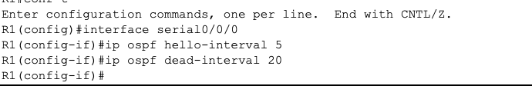
R1(config)#interface serial0/0/0
R1(config-if)#ip ospf hello-interval 5
R1(config-if)#ip ospf dead-interval 20
R1(config-if)#
01:09:04: %OSPF-5-ADJCHG: Process 1, Nbr 10.2.2.2 on Serial0/0/0 from FULL t
DOWN, Neighbor Down: Dead timer expired
01:09:04: %OSPF-5-ADJCHG: Process 1, Nbr 10.2.2.2 on Serial0/0/0 from FULL t
Down: Interface down or detached
 
After 20 seconds, the Dead timer on R1 expires. R1 and R2 lose adjacency because the Dead timer and Hello timer must be set identically on each side of the serial link between R1 and R2.
Step 5: Modify the Dead timer and Hello timer intervals.
Modify the Dead timer and Hello timer intervals on the Serial 0/0/0 interface on router R2 to match the intervals configured on the Serial 0/0/0 interface on router R1.
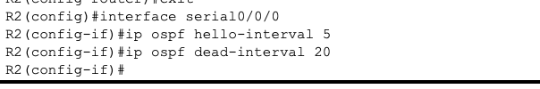
Note that the IOS displays a message when an adjacency has been established with a status of Full.
Step 6: Use the show ip ospf interface serial0/0/0 command to verify that the Hello timer and Dead timer intervals have been changed.
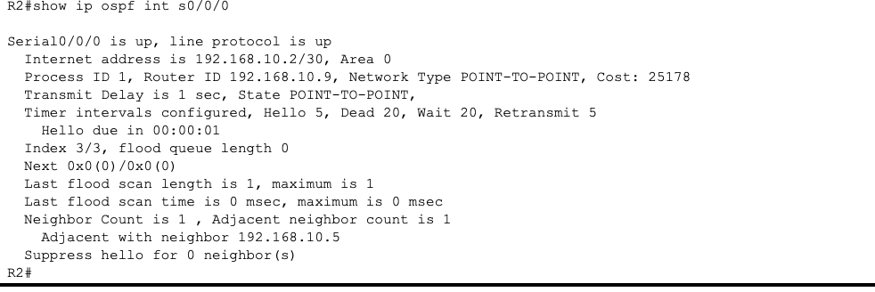 
Step 7: Use the show ip ospf neighbor command on router R1 to verify that the neighbor adjacency with R2 has been restored.
Note that the Dead timer for Serial 0/0/0 is now lower, as it counts down from 20 seconds instead of the default time of 40 seconds. Serial 0/0/1 still works with the default timers.
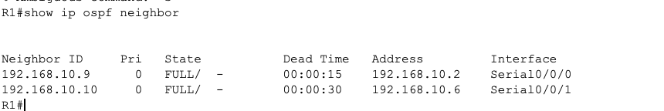
Task 12: Document router configurations.
On each router capture the following command output and save it to a text file for future reference.
Running configuration
Routing table
Interface summary
Result of show ip protocols
Task 13: Cleaning.

Clear the configurations and reload the routers. Disconnect and store the cables. For host PCs that are typically connected to other networks (such as the school LAN or the Internet), reconnect the appropriate cables and reset the TCP/IP settings.

